**CONCORDIA UNIVERSITY**

**COMP6731: PATTERN RECOGNITION**

**Fall 2017**

**PROJECT PROPOSAL**

**Team Members:**

|  |  |  |  |
| --- | --- | --- | --- |
| **Name** | **Family** | **Student ID#** | **Email** |
| Nimisha | Goel | 40026627 | Taurian.nimi08@gmail.com |
| Jaspreet | Randhawa | 40014728 | [Kjaspreet011@gmail.com](mailto:Kjaspreet011@gmail.com) |
| Saiteja | Prasadam | 40041931 | saitejaprasadam@gmail.com |

**Name of the team leader:** Nimisha Goel

**Title of the project:** Car number plate detection

**Brief explanation of the project:** This project is about extracting the number of car number plate from given static images following few constraints.

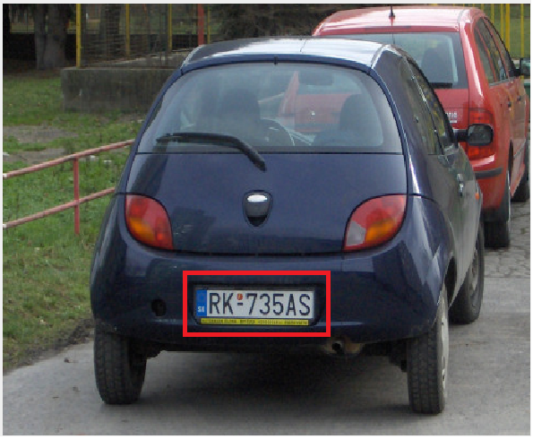

**Motivation**

As the number of cars are increasing every day, it has become difficult to monitor the cars for ensuring enforcement of law and security by the humans. For example, for the purpose of checking invalid license plates, recognizing stolen cars and cars used in illegal activities etc. To address all these issues, we need to have a way or system that detects or recognizes the number plates automatically with least human intervention. So, to meet this purpose we have decided to develop NPD system.

**Challenges**

Some of the challenges in the implementation of such a system can be low image quality, viewpoint and distance changes and complex background.

**Solution**

The implementation will take place in the following manner:

* Getting and analyzing images using different algorithms.
* The algorithms will perform OCR on the analyzed images and will convert it into text format.
* System will check the converted data against the DB.

**Applications**

TC, checking invalid license plates, recognizing stolen cars and cars used in illegal activities, parking.

**Keywords:** Number Plate Detection (NPD), Optical Character Recognition (OCR), Database (DB), Traffic Control (TC), Pattern Recognition (PR), Structured Query Language (SQL).

**Database:** The data for the project will be collected from some online sources. One of the source link is listed as: <http://www.vision.caltech.edu/html-files/archive.html>

The data for PR will be provided to the system using SQL DB or text file.

**Implementation Environment:** Python, OpenCV

**Describe division of the workload among your team members:**

* **Preprocessing**: Nimisha Goel, Jaspreet Randhawa, Saiteja Prasadam
* **Feature extraction**: Nimisha Goel, Jaspreet Randhawa, Saiteja Prasadam
* **Classification:** Nimisha Goel, Jaspreet Randhawa, Saiteja Prasadam
* **Post processing**: Nimisha Goel, Jaspreet Randhawa, Saiteja Prasadam

**Timeline (Gantt chart):**

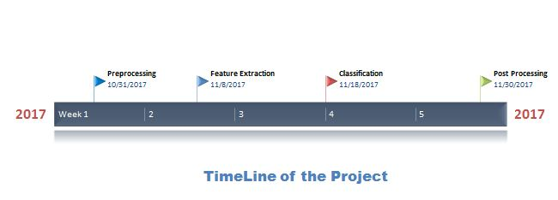

**References:**

[1]K.K. Kim et al, “Learning-Based Approach for License Plate Recognition”.

[2] Christos-Nikolaos E. Anagnostopoulos et al, “License Plate Recognition from still images and video sequences: A Survey”, IEEE Transactions on intelligent transportation systems, Vol. 9, No.3, pp. 377-391, September 2008.

[3] J.A.G. Nijhuis et al,”Car License Plate Recognition with Neural Networks and Fuzzy Logic”.

[4] https://arxiv.org/pdf/1504.01476.pdf.